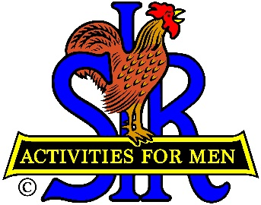
SIR State Bowling Committee
Sir Russ Salazar, Chairman
(530) 644-3809 * RCSALAZAR@AOL.COM

SIR STATE BOWLING COMMITTEE
GENERAL MEETING (ZOOM)
3:00 PM SATURDAY May 8TH, 2021

AGENDA

3:00 - OPENING REMARKS - Sir Russ Salazar, Chairman
Welcome, Flag Salute, Review/Approve Agenda.

3:10 - SECRETARY’S REPORT – Sir Gary Kaufmann, Secretary
Review/Approve Minutes of March 27th General Meeting

3:20 - TREASURER’S REPORT – Sir Larry Mustain, Treasurer
Review/Approve Current Financial Report
3:30 – NEW SIR MANDATE REQUIRING FULL VACCINATIONS – Russ Salazar, Chairman
Review/discussion of SIR State President Stu Williams notice. Discussion of ways to comply with the mandate to continue SIR bowling activities.
4:00 2021 TOURNAMENT SEASON – Sir Ray DiBasilio, Operations Advisor
Current status of bowling resumption, Review of current status of 2021 Tournament Schedule.
4:20 SIR Bowling Tournament Average (SBTA) – Sir Dan Weller, Vice Chairman
Current status and rules for using the SBTA in tournaments.

4:30 – COMMENTS FROM TOURNAMENT MANAGERS/ASSOCIATES – All

4:50 - NEW BUSINESS – Sir Russ Salazar
4:55 - OLD BUSINESS – Sir Russ Salazar
5:00 - CLOSING REMARKS – Sir Russ Salazar
Next meeting (Tentative) – 10:00 AM Saturday June 12, 2021 (Zoom)
5:00 - ADJOURN

