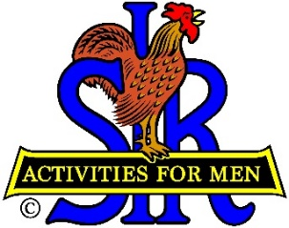
SIR State Bowling Committee
Sir Russ Salazar, Chairman
(530) 644-3809 * RCSALAZAR@AOL.COM

SIR STATE BOWLING COMMITTEE
GENERAL MEETING (ZOOM)
10:00 AM SATURDAY JUNE 26TH, 2021

AGENDA

10:00 - OPENING REMARKS - Sir Russ Salazar, Chairman
Welcome, Flag Salute, Review/Approve Agenda.

10:15 - SECRETARY’S REPORT – Sir Gary Kaufmann, Secretary
Review/Approve Minutes of March 27th General Meeting

10:30 - TREASURER’S REPORT – Sir Larry Mustain, Treasurer
Review/Approve Current Financial Report
10:45 – NEW COVID-19 PROCEDURES – Sir Ray DiBasilio, Operations Advisor
Review/discussion of the new mandated Covid-19 tournament procedures and three tournament experience implementing them. Discussion of participant feedback and possible procedure adjustments.
11:15- 2021 TOURNAMENT SEASON – Sir Ray DiBasilio
Current status of bowling resumption, Review of current status of 2021 Tournament Schedule.
11:30- COMMENTS FROM TOURNAMENT MANAGERS/ASSOCIATES – All

11:45 - NEW BUSINESS – Sir Russ Salazar
Executive Committee vacancies

11:50 - OLD BUSINESS – Sir Russ Salazar
Executive Committee badges

11:55 - CLOSING REMARKS – Sir Russ Salazar
Next meeting (Tentative) – 4:00 PM Monday August 9, 2021 (Reno – in person)
12:00 - ADJOURN

