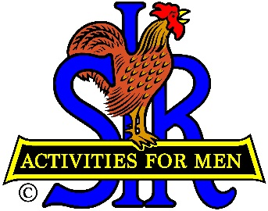
SIR State Bowling Committee
Sir Russ Salazar, Chairman
(530) 644-3809 * RCSALAZAR@AOL.COM

August 3, 2021

Friends:
The SIR State Bowling Committee members, SIR Tournament and League managers, and all the other leaders and organizers of SIR bowling activities are hereby invited to participate in a very important meeting via Zoom to be held at 10:00 AM on Saturday August 21, 2021 instead of the previously announced August 9th in-person meeting in Reno.
By August 21st we will have experienced six SIR bowling tournaments since our resumption of SIR bowling tournaments. We will review our recent experience to determine if adjustments are needed for future tournaments. We will also discuss the remaining six 2021 tournaments. And we will begin discussions of the 2022 bowling tournament schedule. All tournament managers should plan their 2021 SIR tournament dates and coordinate finalization with their bowling center and Sir Ray DiBasilio, Operations Advisor for the Bowling Committee. We will present our 2022 tournament schedule to the SIR State Board for final approval at their October meeting.
Please be prepared to speak about your individual tentative or final plans as they pertain to the 2021 resumption and 2022 tournament plans. A proposed agenda is attached for your review and comment. Please send your comments and/or suggestions directly to me as soon as possible.
Sir Dan Weller will send you an invitation to the Zoom meeting a few days before August 21st with the required meeting ID and password for you to join us. Please RSVP your attendance to Sir Dan ASAP. If you have any questions regarding the issues to be discussed, please contact Sir Ray DiBasilio at (530) 558-9727 or email Ray at RDiBasilio@GMail.com. If you need help regarding participation in the Zoom meeting please contact Sir Dan Weller at (925) 935-5510 or email Dan at DWeller@Astound.net.
Hope to “See” you all on August 21st.
Sir Russ Salazar, Chairman
SIR State Bowling Committee

