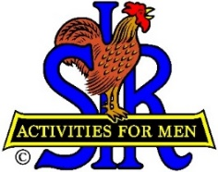
SIR State Bowling Committee
Sir Dan Weller, Chairman
925-935-5510 dweller@astound.net

SIR STATE BOWLING COMMITTEE
GENERAL MEETING (ZOOM)
10:00 AM Saturday, February 5, 2022
AGENDA

10:00 - OPENING REMARKS - Sir Dan Weller, Chairman
Welcome, Flag Salute, Review/Approve Agenda

10:10 - SECRETARY’S REPORT – Sir Gary Kaufmann, Secretary
Discuss Key Items of the January 15 Executive Meeting

10:20 - TREASURER’S REPORT – Sir Larry Mustain, Treasurer
Review/Approve Current Financial Report and results of SIR INC Audit

10:30 – Status of Operations – Sir Ray DiBasilio
Discuss the full tournament calendar and the need for better tournament software.

10:50 - Status of the SIR Tournament Bowling Average (STBA) – SIR Dan Weller

11:00 - Questions and comments from the Tournament Managers and Bowling Chairmen

11:20 - NEW BUSINESS – Sir Dan Weller
Updating our By-Laws and Rules – volunteers needed

11:30 - OLD BUSINESS – Sir Dan Weller
Wine, wine everywhere

11:55 - CLOSING REMARKS – Sir Dan Weller
Next meeting (General Committee) – 10:00 AM Saturday May 7, 2022

12:00 - ADJOURN

