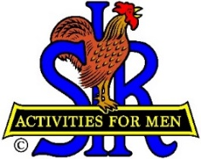
SIR State Bowling Committee
Sir Dan Weller, Chairman
925-935-5510 dweller@astound.net

SIR STATE BOWLING COMMITTEE
EXECUTIVE MEETING (ZOOM)
10:00 AM Saturday, January 15, 2022
AGENDA

10:00 - OPENING REMARKS - Sir Dan Weller, Chairman
Welcome, Flag Salute, Review/Approve Agenda, SIR INC Meeting Highlights

10:10 - SECRETARY’S REPORT – Sir Gary Kaufmann, Secretary
Review/Approve Minutes of October 22 General Meeting

10:20 - TREASURER’S REPORT – Sir Larry Mustain, Treasurer
Review/Approve Current Financial Report and results of SIR INC Audit
10:30 – Review of Officer Duties – Sir Dan Weller
10:30 – Chair and Vicechair
10:40 – Secretary and Assistant
10:50 – Treasurer and Assistant
11:00 – Policy Advisor
11:10 – Operations Advisor
11:20 – Website Manager

11:30 – Status of Operations – Sir Ray DiBasilio

11:40 - NEW BUSINESS – Sir Dan Weller

11:50 - OLD BUSINESS – Sir Dan Weller

11:55 - CLOSING REMARKS – Sir Dan Weller
Next meeting (General Committee) – 10:00 AM Saturday October 5, 2022
12:00 - ADJOURN

