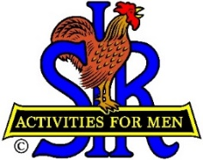
SIR State Bowling Committee
Sir Dan Weller, Chairman
925-935-5510 dweller@astound.net

SIR STATE BOWLING COMMITTEE
GENERAL MEETING (ZOOM)
10:00 AM Saturday, February 4, 2023
AGENDA

10:00 - OPENING REMARKS - Sir Dan Weller, Chairman
Welcome, Flag Salute, Review/Approve Agenda

10:10 - SECRETARY’S REPORT – Sir Gary Kaufmann, Secretary
Review/Approve Prior Meeting

10:20 - TREASURER’S REPORT – Sir Larry Mustain, Treasurer
Review/Approve Current Financial Report

10:50 - POLICY ADVISOR – SIR John Manahan
Status of the Bowling By-Laws and Rules,

11:00 - OPERATIONS ADVISOR– Sir Ray DiBasilio
Status of the Tournament Operations.
Discuss the current status of the 10+ (ten pins over USBC average) rule

11:15 - Questions and comments from the Tournament Managers and Bowling Activity Chairmen

11:25 - NEW BUSINESS – Sir Dan Weller
Looking for a New Web Manager

11:40 - OLD BUSINESS – Sir Dan Weller

11:55 - CLOSING REMARKS – Sir Dan Weller
Next meeting (General Committee) – 10:00 AM Saturday May 6, 2023

12:00 - ADJOURN

