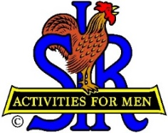

SIR State Bowling Committee
Sir Dan Weller, Chairman
925-935-5510 dweller@astound.net

SIR STATE BOWLING COMMITTEE
GENERAL MEETING (ZOOM)
10:00 AM Saturday, September 9, 2023
AGENDA

10:00 - OPENING REMARKS - Sir Dan Weller, Chairman
Flag Salute, Welcome, Review / Approve Agenda

10:10 - CHAIRMAN COMMENTS – Sir Dan Weller, Chairman

10:20 - SECRETARY’S REPORT – Sir Gary Kaufmann, Secretary
Review / Approve Prior Meeting

10:30 - TREASURER’S REPORT – Sir Larry Mustain, Treasurer
Review / Approve Current Financial Report

10:40 - OPERATIONS ADVISOR– Sir Ray DiBasilio
Status of the Tournament Operations.

11:00 - POLICY ADVISOR – OPEN
Status of the Bowling By-Laws and Rules,

11:15 - Questions and Comments from The Tournament Managers and Branch Bowling Activity Chairmen

11:25 - NEW BUSINESS – Sir Dan Weller
Possible Bowling / Golf Tournament

11:40 - OLD BUSINESS – Sir Dan Weller
Looking for Committee helpers

11:55 - CLOSING REMARKS – Sir Dan Weller
Next meeting (General Committee) – 10:00 AM Saturday September 9, 2023

12:00 - ADJOURN

